**Chapter X (Open edX Architecture)**

X.1 What is Open edX

Open edX is the open source platform software developed by **EdX** and made freely available to other institutions of higher learning that want to make similar offerings. The Open edX project is a web-based platform for creating, delivering, and analysing online courses. It is the software that powers edx.org and many other online education sites.

Main components of Open edX are :

* Edx-platform
* Catalog
* Analytics
* Ecommerce
* Notes API

X.2 Overview

There are a handful of major components to the Open edX project. These components generally communicate using stable, properly documented APIs.

The centrepieceof the Open edX architecture is the edx-platform, which contains the learning management and course authoring applications (LMS and Studio, respectively). The edx-platform in turn is a very complex service which is supported by a collection of other autonomous web services called independently deployed applications (IDAs).

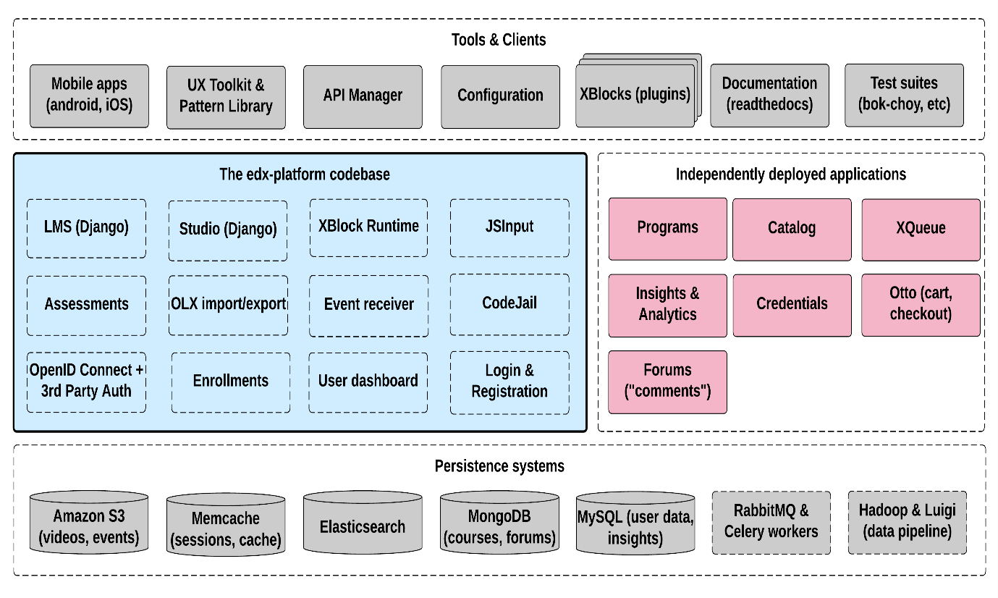

X.2 Key Components

X.2.1 Learning Management System

The Learning Management System or the LMS is the most visible part of the Open edX project. Learners and students access their courses through the LMS and its effective functionalities makes Open edX a efficient MOOC platform. The LMS also provides an instructor dashboard that users who have the Admin or Staff role can access by selecting **Instructor.**

The LMS uses a number of data stores. Courses are stored in MongoDB which is a NoSQL Database, with videos served from YouTube or Amazon S3. Per-learner data is stored in MySQL.

As learners move through courses and interact with them, events are published to the analytics pipeline for collection, analysis, and reporting.

X.2.2 Studio

Studio is the course authoring environment. Course teams use it to create and update courses. Studio writes its courses to the same Mongo database that the LMS uses.

X.2.3 Discussions

Course discussions are managed by an **IDA** called comments (also called forums) comments is one of the few non-Python components, written in **Ruby** using the **Sinatra** framework. The LMS uses an API provided by the comments service to integrate discussions into the learners’ course experience.

The comments service includes a notifier process that sends learners notifications about updates in topics of interest.

X.2.4 Mobile Apps

The Open edX project includes a mobile application, available for iOS and Android, that allows learners to watch course videos and more. EdX is actively enhancing the mobile app.

X.2.5 Analytics

Events describing learner behavior are captured by the Open edX analytics pipeline. The events are stored as **JSON** in S3, processed using **Hadoop**, and then digested, aggregated results are published to **MySQL**. Results are made available via a **REST API** to Insights, an IDA that instructors and administrators use to explore data that lets them know what their learners are doing and how their courses are being used.

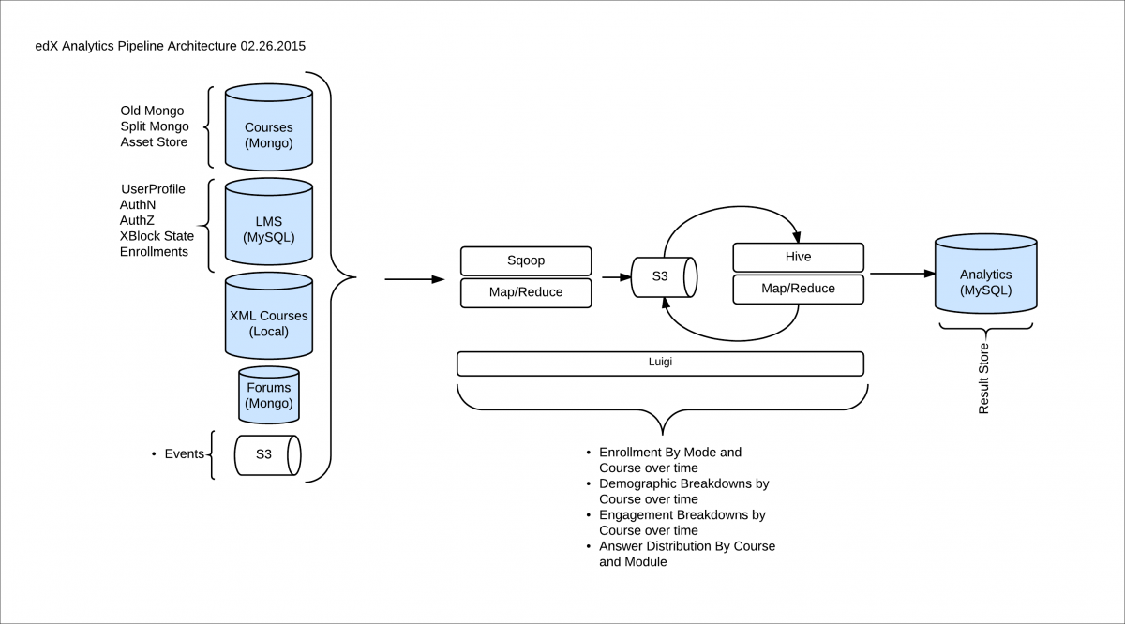

X.2.6 Background work

A number of tasks are large enough that they are performed by separate background workers, rather than in the web applications themselves. This work is queued and distributed using **Celery** and **RabbitMQ**. Examples of queued work include:

* Grading entire courses
* Sending bulk emails (with Amazon SES)
* Generating answer distribution reports
* Producing end-of-course certificates

The Open edX project includes an IDA called **XQueue** that can run custom graders. These are separate processes that run compute-intensive assessments of learners’ work.

X.2.7 Search

The Open edX project uses **ElasticSearch** for searching in multiple contexts, including course search and the comments service.